LINUX SYSTEM DEBUGGING TOOL (LDST)
A Project Report Submitted in Partial Fulfillment of the Requirements for the Award of the Degree of
BACHELOR OF TECHNOLOGY
in
DEPARTMENT OF COMPUTER SCIENCE AND ENGINEERING
By
Student Name | Registration Number
M. Nihal | 2520030124
Madhan Gopal | 2520030263
Thrinadh | 2520030529

Under the Esteemed Guidance of
[Guide Name]
Department of Computer Science and Engineering
K L (Deemed to be) University
Academic Year 2026-2027

DECLARATION
We hereby declare that the project report entitled “Linux System Debugging Tool (LDST)” is a record of the bonafide work carried out by M. Nihal (2520030124), Madhan Gopal (2520030263), and Thrinadh (2520030529) in partial fulfillment of the requirements for the award of the Bachelor of Technology degree in Computer Science and Engineering. The work presented in this report is based on our project design, implementation, testing, and study of Linux operating-system debugging mechanisms. To the best of our knowledge, the results and material presented here have not been copied from another project report.

Student | Registration Number | Signature
M. Nihal | 2520030124
Madhan Gopal | 2520030263
Thrinadh | 2520030529

CERTIFICATE
This is to certify that the project report entitled “Linux System Debugging Tool (LDST)” is a bonafide project work carried out by the above students in the Department of Computer Science and Engineering, K L (Deemed to be) University, during the academic year 2026-2027, in partial fulfillment of the requirements for the award of the degree of Bachelor of Technology.

Signature of the Guide | Signature of the Course Coordinator | Signature of the HOD

ACKNOWLEDGEMENT
We express our sincere gratitude to our guide, course coordinator, Head of the Department, faculty members, technical staff, classmates, friends, and family members who supported us during the development of this project. Their guidance and feedback helped us understand Linux process execution, debugging, system calls, signals, error handling, and the practical challenges involved in integrating low-level debugging tools with a user-friendly interface.
We also acknowledge the GNU and Linux communities for providing GCC, GDB, strace, the Linux /proc interface, and related documentation that made it possible to study and build a practical debugging environment.

ABSTRACT
The Linux System Debugging Tool (LDST) is a Linux-based debugging application designed to make low-level C program execution and failure analysis easier to understand. The project combines a C systems-programming core with a local web-based graphical interface. It allows users to create or select C programs, compile them using GCC, execute them under controlled conditions, inspect source-level execution, analyze failed system calls and errno values, identify signals and termination status, and generate structured debugging reports.
The interactive Debugger is designed around real source-level debugging using GNU GDB through its machine-oriented interface. It supports operations such as Start Debugging, Next, Step Into, Step Out, Continue, Breakpoints, and Stop. At valid debugger stops, LDST can present the current source location, function, local variables, function arguments, call stack, target-program output, signals, and final termination state. Source highlighting is based on actual executable locations reported by GDB rather than simulated movement through text lines.
The AutoDebugger provides a separate automatic workflow. It compiles and executes a selected program, collects relevant Linux runtime evidence using mechanisms such as strace, errno, process termination status, signals, and GDB crash information when appropriate, and then produces a structured diagnosis. LDST distinguishes normal termination, non-zero exit status, handled system-call errors, and signal-based crashes. The project therefore demonstrates important operating-system concepts including process creation and execution, waiting and termination, file operations, system-call tracing, errno-based error handling, signals, /proc-based runtime information, and source-level debugging.

INDEX
S. No. | Chapter / Topic
 | Acknowledgement
 | Abstract
1 | Introduction
1.1 | Background of the Project
1.2 | Problem Statement
1.3 | Scope of the Project
1.4 | Objectives of the Project
1.5 | Importance of the Application
1.6 | Target Users / Audience
2 | OS Concepts and Background Study
2.1 | Operating System Concepts Related to the Project
2.2 | Existing Methods / Algorithms
2.3 | Proposed Approach
2.4 | Advantages of the Proposed Approach
3 | System Requirements
3.1 | Hardware Requirements
3.2 | Software Requirements
3.3 | Operating System Environment - Ubuntu / WSL
3.4 | Development Tools and Compilers
4 | Technology and Tools Used
4.1 | C / C++ Programming
4.2 | GCC Compiler
4.3 | Linux System Calls
4.4 | POSIX Threads / Synchronization
4.5 | Linux Commands and Utilities
4.6 | Other Tools / Libraries Used
5 | System Architecture and Design
5.1 | Overall System Architecture
5.2 | System Workflow
5.3 | Flowchart / Data Flow
5.4 | Module Description
5.5 | Input and Output Design
6 | Implementation
6.1 | Module-wise Implementation
6.2 | Algorithm / Pseudocode
6.3 | Core C / C++ Implementation
6.4 | Linux System Calls / APIs Used
6.5 | Process / Thread Implementation
6.6 | IPC / Synchronization Implementation
6.7 | Memory Management Implementation
6.8 | User Interface Implementation
7 | Execution and Demonstration
7.1 | Compilation in Ubuntu
7.2 | Execution Commands
7.3 | Sample Inputs and Outputs
7.4 | Screenshots of Execution
7.5 | Demonstration of OS Concepts
8 | Conclusion
8.1 | Summary of the Project
8.2 | Objectives Achieved
8.3 | Results Achieved
8.4 | Skills and Learning Outcomes
9 | References
9.1 | Books
9.2 | Research Papers
9.3 | Linux / GNU Documentation
9.4 | Online Resources

CHAPTER 1 - INTRODUCTION

1.1 Background of the Project
Debugging is an essential activity in systems programming because a program may compile successfully and still fail during execution. A C program running on Linux interacts with the operating system through processes, files, system calls, signals, memory, and runtime libraries. When a failure occurs, a developer may need several tools to understand it: GCC for compilation diagnostics, GDB for source-level execution and crash investigation, strace for system-call tracing, errno for operation failures, and Linux process-status information for termination analysis.
For beginners, these tools are powerful but fragmented. A student may know that a program has crashed without knowing which source statement caused it, or may see an errno such as ENOENT without understanding which operation failed. LDST was conceived as an integrated educational debugging environment that brings these pieces together and presents the evidence through both terminal and web-based interfaces.

1.2 Problem Statement
Existing command-line debugging tools generally require separate commands, different output formats, and prior knowledge of Linux debugging. A learner must manually compile the program, start GDB, set breakpoints, inspect variables, run strace separately, interpret errno values, and determine whether the process exited normally or was terminated by a signal. This makes debugging difficult for students who are still learning operating-system concepts.
The problem addressed by LDST is therefore to provide one local Linux debugging environment that performs real compilation and execution, supports interactive source-level debugging, performs automatic runtime analysis, and presents the collected evidence in a clear and structured form without fabricating errors or results.

1.3 Scope of the Project
- Creation and management of C test programs inside the project workspace.
- Compilation of programs using GCC with warning and debugging options.
- Interactive source-level debugging using GDB/GDB-MI concepts.
- Automatic analysis of program execution using strace, errno, exit status, signals, and GDB crash evidence when appropriate.
- Detection and classification of normal exit, non-zero exit, signal-based termination, timeout, and user-stopped sessions.
- Presentation of source location, variables, function arguments, call stack, program output, and relevant low-level evidence.
- Generation and storage of structured debugging reports.
- Local web interface for controlling debugging operations while preserving the Linux backend.

1.4 Objectives of the Project
- To provide a practical Linux debugging environment for C programs.
- To compile programs with real GCC and display actual diagnostics.
- To allow interactive source-level execution through Next, Step Into, Step Out, Continue, Breakpoints, and Stop.
- To collect real runtime evidence rather than simulated or hard-coded errors.
- To analyze relevant system-call failures and errno values.
- To identify process exit status and signal-based abnormal termination.
- To use GDB information for source locations, variables, stack frames, and crash analysis.
- To separate manual Debugger and automatic AutoDebugger workflows.
- To generate understandable reports for learning, demonstration, and later review.

1.5 Importance of the Application
LDST connects theoretical operating-system concepts with observable program behavior. Instead of only reading about fork, exec, wait, signals, file descriptors, errno, or process termination, students can run programs and see how these mechanisms affect execution. The tool is especially useful for demonstrations because it combines source-level and operating-system-level evidence in one place.

1.6 Target Users / Audience
The primary audience is students studying Operating Systems, Systems Programming, Linux, and C programming. It can also assist beginner developers who want a guided view of program execution and instructors who need controlled examples of system-call errors, abnormal termination, and source-level debugging.

CHAPTER 2 - OS CONCEPTS AND BACKGROUND STUDY

2.1 Operating System Concepts Related to the Project
Concept | Use in LDST
Process creation | A target program is launched as a separate process.
Program execution | exec-family behavior replaces a child process image with the selected executable.
Process waiting | wait/waitpid-style logic obtains completion and termination information.
System calls | Runtime interactions such as file I/O are visible through Linux tracing.
File descriptors | Tests demonstrate valid and invalid descriptors and errors such as EBADF.
errno | Explains failures such as ENOENT, EBADF, and EACCES.
Signals | Used to identify abnormal events such as SIGSEGV, SIGFPE, SIGABRT, and SIGTERM.
/proc | Provides available runtime process information when relevant.
Debug information | GCC -g maps machine execution back to source-level locations.
Source-level debugging | GDB controls breakpoints, stepping, frames, variables, and signal stops.

2.2 Existing Methods / Algorithms
Traditional Linux debugging is usually performed by using each tool independently. GCC reports compile-time diagnostics; GDB performs source-level debugging; strace records system calls and signals; shell tools inspect process state; and the developer manually combines the evidence. This method is flexible but requires knowledge of multiple command syntaxes and careful interpretation.
A second common approach is to build simple teaching tools that only scan source text or search logs for keywords. Such an approach is not sufficient for LDST because a source line being displayed does not prove that the line executed. LDST therefore requires runtime evidence from the actual compiler, debugger, tracer, and process status.

2.3 Proposed Approach
LDST proposes an integrated workflow with two complementary debugging modes. The interactive Debugger uses GDB as the source-level execution engine while LDST provides session management and a graphical control layer. The AutoDebugger performs an automatic run and collects evidence such as compiler diagnostics, system-call failures, errno, exit status, signals, and crash information.
Selected / Created C Program
|
v
GCC
(-g -O0)
|
+-------------------------+
| |
v v
Interactive Debugger AutoDebugger
GDB / MI Automatic execution
| strace + errno
| exit/signal status
| GDB crash evidence
+-----------+-------------+
|
v
LDST Analysis
|
v
GUI + Final Report

2.4 Advantages of the Proposed Approach
- Uses real Linux tools and runtime evidence.
- Separates interactive debugging from automatic diagnosis.
- Provides source-level context and low-level OS evidence together.
- Reduces the need to memorize many GDB and strace commands.
- Distinguishes handled errors from actual crashes.
- Preserves raw evidence while also providing an understandable interpretation.
- Suitable for controlled academic demonstrations and custom student programs.

CHAPTER 3 - SYSTEM REQUIREMENTS

3.1 Hardware Requirements
Component | Recommended Requirement
Processor | 64-bit dual-core or better
RAM | 4 GB minimum; 8 GB recommended
Storage | At least 1 GB free for project, packages, binaries, and reports
Display | 1366 x 768 or higher for comfortable web dashboard use
Network | Not required for local debugging after dependencies are installed

3.2 Software Requirements
Software | Purpose
Ubuntu Linux / WSL2 Ubuntu | Execution environment
GCC | C compilation
GDB | Source-level debugging and crash analysis
strace | System-call and signal tracing
Python 3 | Web/backend controller
Flask | Local web application framework
HTML/CSS/JavaScript | Web user interface
Modern browser | Access to local LDST dashboard
make / shell utilities | Build and project scripts

3.3 Operating System Environment - Ubuntu / WSL
LDST is intended for a Linux environment because its core functionality depends on Linux process behavior, signals, /proc, strace, GCC, and GDB. It can be used on native Ubuntu or a suitable Ubuntu environment under WSL2. The web interface remains local and is normally accessed through the loopback address 127.0.0.1.

3.4 Development Tools and Compilers
The main development tools are GCC for compiling C test programs, GDB for debugging, strace for runtime tracing, Python and Flask for the web bridge, and standard Linux shell/build utilities for setup and execution. Debugging builds should use -g and -O0 so that source locations and variable information are available with minimal optimization-related distortion.

CHAPTER 4 - TECHNOLOGY AND TOOLS USED

4.1 C / C++ Programming
The project focuses on C programs because C exposes operating-system interactions clearly. Test programs can directly demonstrate file descriptors, system calls, pointers, signals, process behavior, return codes, and memory errors. The core test cases are written in C11-compatible form.

4.2 GCC Compiler
GCC compiles both built-in and user-created C programs. A typical debugging compilation command is:
gcc -Wall -Wextra -std=c11 -g -O0 tests/program.c -o tests/program
Option | Meaning
-Wall | Enables common compiler warnings.
-Wextra | Enables additional useful warnings.
-std=c11 | Uses the C11 language standard.
-g | Adds debugging information used by GDB.
-O0 | Disables optimization to improve source-level debugging fidelity.
-o | Specifies the output executable.

4.3 Linux System Calls
The project explicitly demonstrates important Linux/POSIX process and file-operation functions. During actual execution, strace may reveal many additional system calls generated by the C library and runtime loader.
Function | Role in the project
fork() | Creates a child process for controlled execution.
exec()/execvp() | Loads and executes the selected target program.
wait() | Waits for child-process completion.
waitpid() | Obtains termination information for a particular child.
open() | Opens files and can demonstrate errors such as ENOENT/EACCES.
read() | Reads from file descriptors and can demonstrate EBADF.
write() | Writes to file descriptors and can demonstrate EBADF.
close() | Closes file descriptors.

4.4 POSIX Threads / Synchronization
POSIX threads are not a primary requirement of the present LDST design. The core debugger is process-oriented rather than a multithreaded application exercise. The web backend may use normal server-side concurrency/session handling to remain responsive, but LDST does not claim pthread synchronization as a major implemented OS feature unless a dedicated multithreaded target test is added.

4.5 Linux Commands and Utilities
Utility | Purpose
gcc | Compile C programs.
gdb | Interactive source debugging and crash investigation.
strace | Trace system calls and signals.
make | Build automation.
chmod | Set executable permissions on scripts.
ps / proc tools | Support process inspection when needed.
bash | Run setup, launch, and self-test scripts.

4.6 Other Tools / Libraries Used
Python Flask connects the browser interface to the local Linux debugging backend. HTML, CSS, and JavaScript implement the dashboard, program editor, Debugger, AutoDebugger, results, and reports pages. Structured report formats such as JSON and human-readable TXT make the results reusable outside the live session.

CHAPTER 5 - SYSTEM ARCHITECTURE AND DESIGN

5.1 Overall System Architecture
LDST WEB INTERFACE
Dashboard | Test Programs | Create Program | Debugger
| AutoDebugger | Results | Reports
|
v
FLASK / LDST BACKEND
|
+----------------+----------------+
| |
v v
INTERACTIVE DEBUGGER AUTODEBUGGER
GDB / MI automatic runner
| strace / errno
source location exit / signals
variables / args GDB crash evidence
stack / breakpoints |
+----------------+----------------+
|
v
ANALYSIS + REPORTING
|
JSON / TXT / GUI
The standalone System Monitor is intentionally not part of the final navigation. Process information from /proc may still be collected internally when it contributes useful evidence to a debugging session.

5.2 System Workflow
- User selects an existing test program or creates a new C source file.
- LDST validates the source path and compiles the program using GCC.
- If compilation fails, actual GCC diagnostics are displayed and execution does not begin.
- For interactive debugging, LDST starts a GDB session and stops at an executable source location such as main().
- The user controls execution using Next, Step Into, Step Out, Continue, Breakpoints, or Stop.
- At debugger stops, LDST retrieves available source location, variables, arguments, stack frames, output, and signal/exit state.
- For AutoDebugger, LDST executes the program automatically and collects relevant tracing and termination evidence.
- LDST classifies the outcome and creates a structured result/report.

5.3 Flowchart / Data Flow
START
|
Select/Create C Program
|
Validate Source
|
Compile with GCC
|
+---- Compilation Failed? ---- YES ---> Show GCC Diagnostics ---> END
| NO
v
Choose Mode
|
+------------------------+
| |
Debugger AutoDebugger
| |
Start GDB Automatic Run
| Collect Evidence
Step/Next/etc. Analyze Errors
| |
Stopped/Exited? |
+-----------+------------+
v
Classify Termination
|
Generate Result/Report
|
END

5.4 Module Description
Module | Description
Dashboard | Entry point showing project status and quick actions.
Test Programs | Lists built-in and user-created C programs.
Create Program | Creates and saves custom C source programs.
Compiler | Runs GCC and returns real diagnostics.
Debugger | Interactive GDB-backed source-level debugging.
AutoDebugger | Automatic runtime investigation and diagnosis.
Analysis Engine | Correlates termination, errno, signals, tracing, and source evidence.
Latest Result | Displays the most recent analysis.
Reports | Stores and presents previous debugging sessions in structured formats.

5.5 Input and Output Design
Inputs include C source code, selected target program, debugger commands, breakpoint locations, tracing options, and execution limits. Outputs include compiler diagnostics, source locations, variable values, call stacks, stdout/stderr, relevant system-call failures, errno values, signals, exit codes, diagnostic interpretation, and final reports.

CHAPTER 6 - IMPLEMENTATION

6.1 Module-wise Implementation

6.1.1 Program Creation and Test Management
The program-management module stores controlled C source files in the project test-program area. User-supplied filenames must be validated so that a request cannot escape the permitted directory. A newly created source file can then be compiled and used by both Debugger and AutoDebugger.

6.1.2 Compiler Module
The compiler module invokes GCC with argument lists rather than unsafe command concatenation. Standard output and standard error are captured. A failed compilation prevents execution of an old or stale binary and the real GCC message is returned to the interface.

6.1.3 Interactive Debugger Module
The interactive debugger is designed as a session-oriented controller around GDB. GDB/MI is preferred because it emits structured result and asynchronous records that can be mapped to source locations, frames, variables, breakpoints, signals, and process exit events. LDST does not simulate execution by highlighting source text on a timer.
User Action | Debugger Operation
Start | Compile with -g -O0, launch GDB, stop at main/first valid source location.
Next | Execute the next source-level operation without intentionally entering called functions.
Step Into | Enter a debuggable called function.
Step Out | Finish the current function and return to its caller.
Continue | Run until breakpoint, signal, exit, or another stop event.
Breakpoint | Insert/remove a breakpoint at a valid executable location.
Stop | Interrupt/terminate the active session and clean up processes.

6.1.4 AutoDebugger Module
AutoDebugger performs a complete run without requiring the user to step manually. It collects compilation status, target output, relevant system-call failures, errno information, process termination status, signals, and GDB crash information when appropriate. Its purpose is to answer: what happened, what evidence supports that conclusion, and what action should the user consider next.

6.1.5 Reporting Module
Each completed analysis is converted into a structured report containing the program, analysis type, result, timing, observed evidence, and interpretation. Reports can be presented in the web interface and stored in formats such as JSON and TXT.

6.2 Algorithm / Pseudocode
INTERACTIVE_DEBUG(program):
validate(program)
result = compile(program, flags = -Wall -Wextra -std=c11 -g -O0)
if result.failed:
return COMPILATION_FAILED(result.diagnostics)
session = start_gdb_mi(program)
set_breakpoint(main)
run_target()
while session.active:
event = wait_for_gdb_event()
if event is STOPPED:
collect current frame
collect source file and line
collect locals and arguments
collect stack frames
update program output
wait for user command
if event is SIGNAL_RECEIVED:
collect signal + frame + backtrace
classify as signal stop / abnormal termination as appropriate
if event is EXITED:
collect exit status
classify normal or non-zero exit
finalize report
break
cleanup(session)
AUTO_DEBUG(program):
validate(program)
compile program
if compilation fails:
return real GCC diagnostics
execute target under controlled automatic analysis
collect stdout/stderr
collect relevant strace evidence
collect errno-related failures
collect exit/signal status
if crash investigation is appropriate:
collect GDB crash location/backtrace
correlate evidence
classify result
generate diagnosis and report

6.3 Core C / C++ Implementation
The project uses C test programs to demonstrate successful execution and failure conditions. These programs intentionally exercise Linux behavior so that LDST can verify its analysis against controlled cases.
#include <stdio.h>
#include <fcntl.h>
#include <unistd.h>
#include <errno.h>
#include <string.h>
int main(void) {
int fd = open("missing_file.txt", O_RDONLY);
if (fd == -1) {
printf("errno: %d\n", errno);
printf("error: %s\n", strerror(errno));
return 1;
}
close(fd);
return 0;
}
The example above demonstrates a handled ENOENT-style failure. The failed open operation is an error condition, but it is not a segmentation fault or signal-based crash. LDST must preserve this distinction.

6.4 Linux System Calls / APIs Used
The project demonstrates process-control and file-I/O functions including fork, exec/execvp, wait, waitpid, open, read, write, and close. The tracer can observe additional Linux system calls produced internally by libraries and the runtime. LDST should filter interpretation carefully so that harmless loader probes are not automatically treated as the root cause of an application problem.

6.5 Process / Thread Implementation
The main implementation model is process based. A selected executable runs as a target process under controlled supervision. Process completion is interpreted using exit status and signal information. The web application must not block indefinitely while a debugger is running; therefore debugging state is maintained as a session and frontend requests query or update that session.

6.6 IPC / Synchronization Implementation
The project does not require a custom shared-memory or message-queue subsystem as a core feature. Communication between the Flask backend and GDB is performed through the debugger process's standard communication channels / machine interface, while browser-to-backend communication uses local HTTP requests. Session state must be protected against invalid simultaneous operations such as issuing Next after a process has already exited.

6.7 Memory Management Implementation
Memory behavior is important primarily in the target programs being debugged. GDB allows LDST to observe pointer values, local variables, stack frames, and crash locations. Controlled tests such as dereferencing a NULL pointer demonstrate SIGSEGV handling. LDST itself must also clean up subprocesses and avoid leaving orphan GDB or target processes.

6.8 User Interface Implementation
The web interface uses a professional local developer-tool layout. The Debugger view should contain a source-code area with current-line highlighting, session status, variables and arguments, call stack, program output, errors/signals, and optional low-level evidence. Controls are enabled according to the debugger state so that impossible operations are prevented.
State | Meaning
NOT_STARTED | No active debugger session.
COMPILING | GCC is compiling the target.
STARTING | Debugger is being initialized.
STOPPED | Target is paused at a debugger stop.
RUNNING | Target is executing.
EXITED | Target completed with an exit status.
SIGNALED | Target encountered signal-based abnormal termination.
USER_TERMINATED | User intentionally stopped the session.
ERROR | Debugger/session error occurred.

CHAPTER 7 - EXECUTION AND DEMONSTRATION

7.1 Compilation in Ubuntu
From the project directory, the setup/build scripts can be made executable and executed. Individual C programs can also be compiled directly for verification.
chmod +x setup.sh run.sh selftest.sh
./setup.sh
gcc -Wall -Wextra -std=c11 -g -O0 tests/file_error.c -o tests/file_error

7.2 Execution Commands
./run.sh
# Open the local LDST web interface in the browser:
# http://127.0.0.1:5000
./selftest.sh
# Optional direct verification:
./tests/file_error
strace ./tests/file_error
gdb ./tests/segmentation_fault

7.3 Sample Inputs and Outputs
Test | Expected Classification | Important Evidence
Normal arithmetic program | Normal completion | Exit code 0; expected stdout.
Function call | Normal / interactive | Step Into enters function; Step Out returns.
Missing file | Handled system-call error / non-zero exit depending program | open/openat failure with ENOENT.
Invalid descriptor | Handled system-call error / non-zero exit depending program | read/write returns EBADF.
NULL pointer dereference | Signal-based abnormal termination | SIGSEGV with GDB source location/backtrace.
Arithmetic signal test | Signal-based abnormal termination | Actual signal such as SIGFPE when produced by the test.
return 1 | Non-zero exit | Exit code 1; no false crash classification.
Invalid C syntax | Compilation failure | Real GCC diagnostics; debugger not started.

7.4 Screenshots of Execution
Insert final screenshots from the completed LDST build in this section. Recommended screenshots are: Dashboard, Test Programs/Create Program, interactive Debugger stopped at a source line, Variables and Call Stack panels, AutoDebugger ENOENT result, AutoDebugger SIGSEGV result, normal completion result, and Reports history. Screenshots should show actual project output and should not be fabricated.
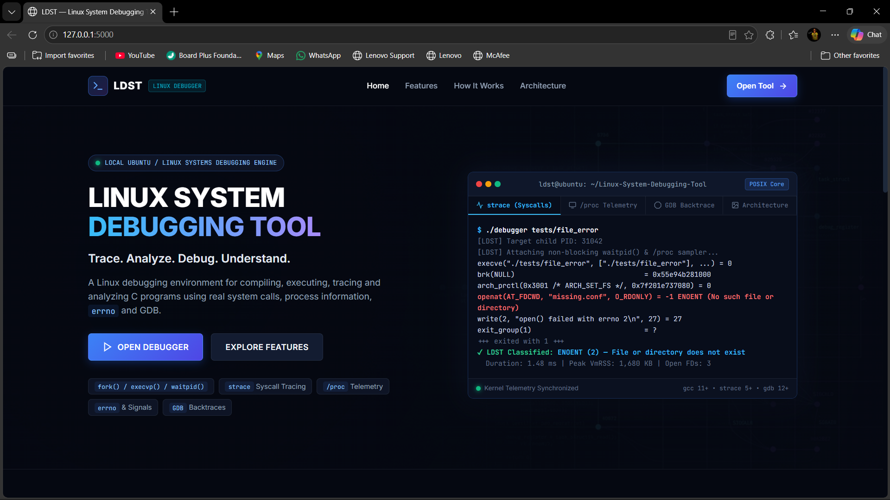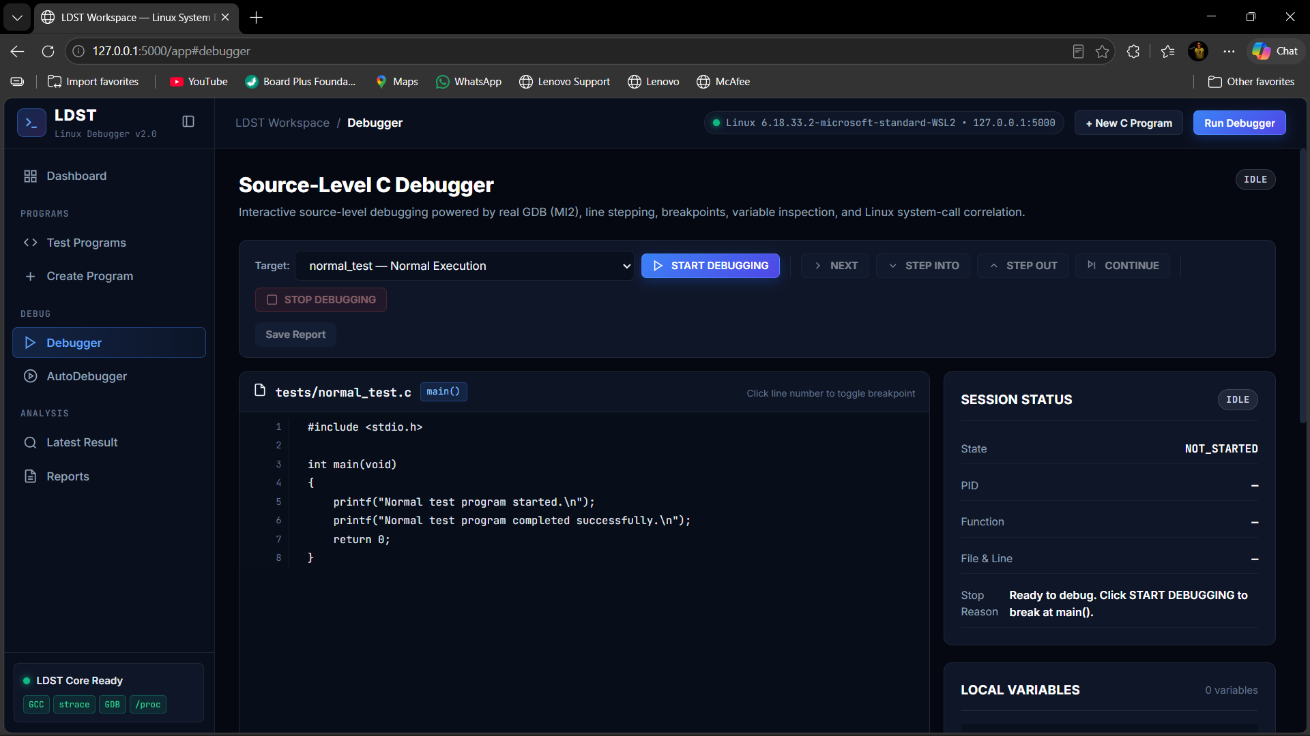
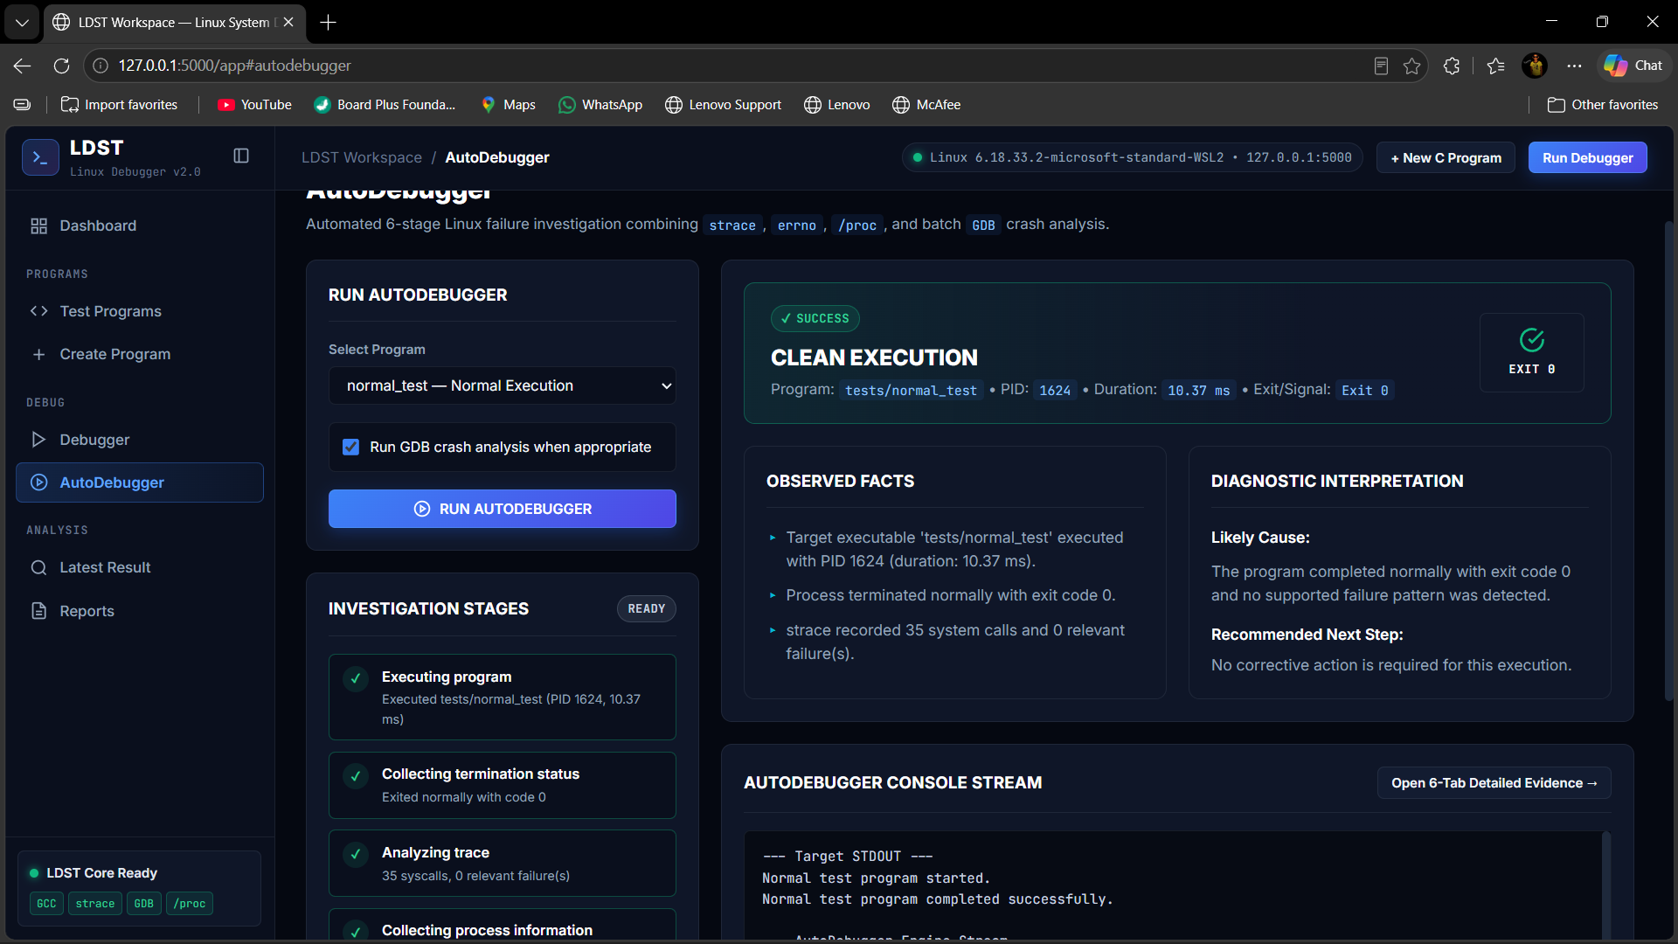
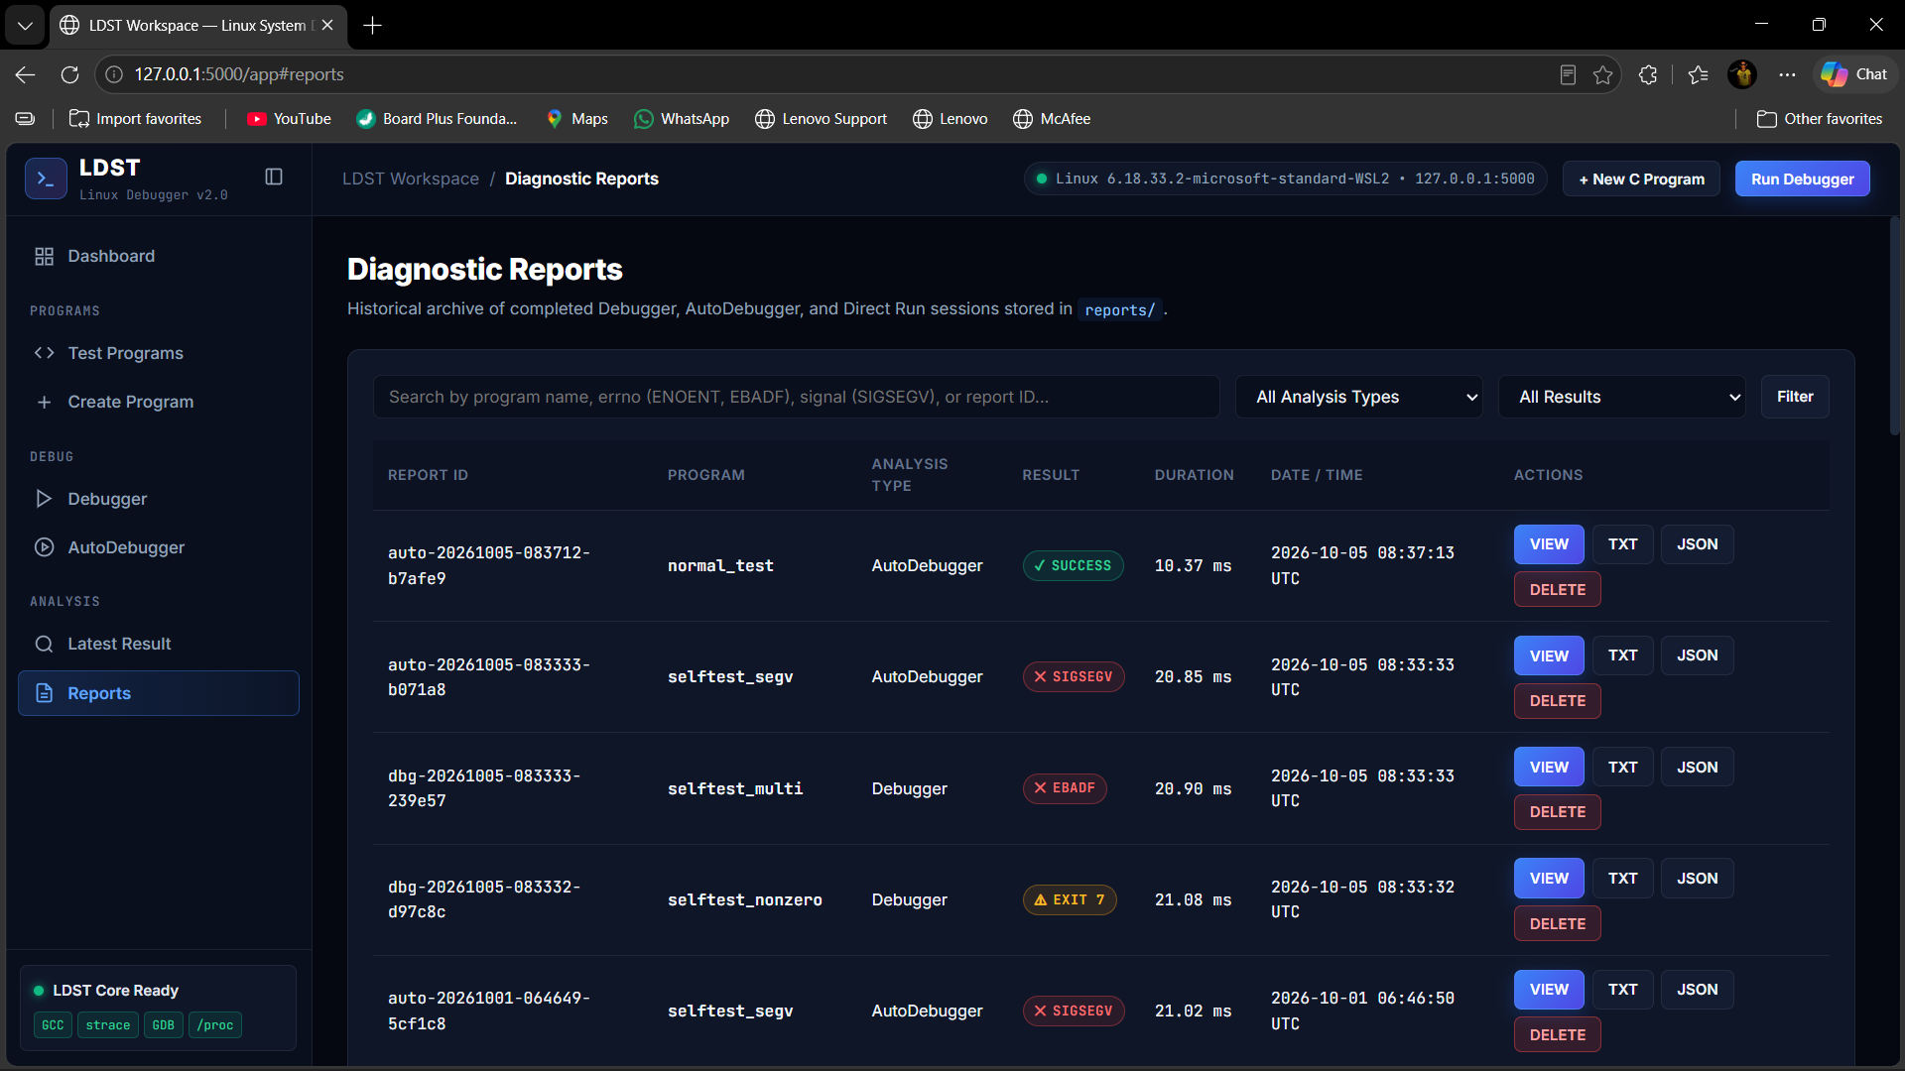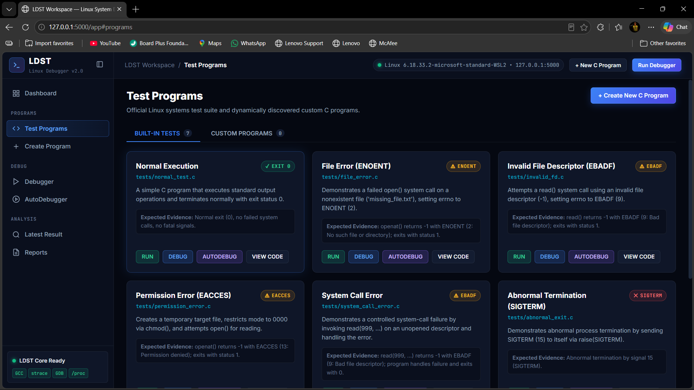

7.5 Demonstration of OS Concepts
OS Concept | Demonstration
Process execution | LDST launches and supervises a selected target.
fork/exec/wait/waitpid | Process-control path used/demonstrated by the debugging workflow.
System calls | strace reveals actual runtime calls.
errno | Failed operations are mapped to symbolic error information.
Signals | SIGSEGV/SIGTERM/etc. are distinguished from normal exits.
File descriptors | Invalid descriptor tests demonstrate EBADF.
Source-level execution | GDB maps execution to executable source locations.
Stack frames | GDB backtrace demonstrates nested function execution.
/proc | Available runtime process information may be collected when relevant.

CHAPTER 8 - CONCLUSION

8.1 Summary of the Project
LDST is an integrated Linux debugging environment that combines real compiler, debugger, tracer, and process-termination evidence behind a simpler interface. Its interactive Debugger focuses on controlled source-level investigation, while AutoDebugger focuses on automatic evidence collection and diagnosis. This separation makes the project useful both for learning how a program executes and for quickly understanding why it failed.

8.2 Objectives Achieved
- Designed an integrated workflow for compiling, executing, debugging, and analyzing C programs.
- Provided a clear separation between interactive Debugger and automatic AutoDebugger responsibilities.
- Used Linux-native debugging concepts instead of simulated error generation.
- Supported analysis of compiler failures, system-call errors, errno values, signals, and process termination.
- Designed structured reporting and a local web interface for easier interpretation.
- Demonstrated core Operating Systems and Systems Programming concepts through controlled test programs.

8.3 Results Achieved
The expected final result is a working local LDST application in which a user can select or create a C program, compile it, investigate executable source locations interactively, or request automatic analysis. The system should correctly distinguish successful completion, non-zero exit, handled operating-system errors, and signal-based crashes, and should show only evidence obtained from real execution.
Final numerical test-pass counts should be inserted only after running the completed self-test and verification suite. This report intentionally does not invent a pass percentage.

8.4 Skills and Learning Outcomes
- Linux process management and termination analysis.
- C systems programming and file-descriptor operations.
- GCC compilation and diagnostic interpretation.
- GDB source-level debugging, breakpoints, variables, and stack frames.
- System-call tracing and errno analysis.
- Signals and abnormal process termination.
- Python/Flask backend integration with native Linux tools.
- Web interface design for developer tooling.
- Safe subprocess execution, path validation, timeouts, and cleanup.
- Technical documentation, testing, and evidence-based debugging.

CHAPTER 9 - REFERENCES

9.1 Books
1. W. Richard Stevens and Stephen A. Rago, Advanced Programming in the UNIX Environment, Addison-Wesley.
2. Michael Kerrisk, The Linux Programming Interface, No Starch Press.
3. Brian W. Kernighan and Dennis M. Ritchie, The C Programming Language, Prentice Hall.

9.2 Research Papers
Research-paper references may be added if the final submission requires a literature survey. Only papers actually consulted by the team should be listed here.

9.3 Linux / GNU Documentation
GNU Compiler Collection (GCC) documentation.
GNU Debugger (GDB) documentation, including GDB Machine Interface documentation.
Linux manual pages for fork, exec, wait, waitpid, open, read, write, close, errno, signals, and proc.
strace documentation and manual pages.

9.4 Online Resources
Official GNU and Linux documentation should be preferred for technical reference. Any additional online resources used during implementation should be recorded with title, organization/author, and access date in the final submitted copy.

APPENDIX A - VIVA QUICK REFERENCE
Question | Short Answer
Is LDST debugger our own? | LDST is our own debugger application and integration layer; GDB is the underlying source-debugging engine.
What is GDB? | GNU Debugger. LDST uses it for real source-level stepping, variables, frames, breakpoints, signals, and crash locations.
Debugger vs AutoDebugger? | Debugger is interactive/manual source-level investigation; AutoDebugger automatically runs, collects evidence, analyzes, and reports.
What is strace? | A Linux tracing utility that records system calls and signals made during program execution.
What is errno? | The standard error-reporting mechanism used by many failed C/POSIX operations.
Does a failed syscall mean a crash? | No. A program may handle the failure and continue or return a non-zero status.
Does return 1 mean crash? | No. It is a non-zero normal process exit unless a signal or other abnormal event occurred.
Why -g -O0? | -g adds debug information; -O0 minimizes optimization so source-level debugging is easier to follow.
Can GDB stop on comments/braces? | No. It stops at executable source locations generated by the compiler, not every textual line.
Why no standalone System Monitor? | It is not central to the debugging objective. Relevant process information can be collected inside a debugging session.

